*Abstract*

GROWTH RESPONSE OF CHRYSANTHEMUM (MORIFOLIUM) TO COMPOST TEA/MYCORRHIZAE

O. Valentin, A Heater- Parkside High CTE, Wicomico Maryland FFA

There have been enormous amounts of studies related to the positive impacts of using compost tea and beneficial mycorrhizae in organic crop and turf management. These studies have shown that both the tea and mycorrhizae provide protection against pathogens and stimulate productivity of crops and grasses. However, there has been both few studies or adoption in the greenhouse container production setting that tests their efficiency related to ornamental or vegetable plant production.

This study conducted, used two regimens of liquid compost/mycorrhizae as an addendum through fertigation to the normal fertilization during summer production of Chrysanthemums. Chrysanthemum production requires relative large amounts of fertilizer to both establish plants and maintain fertility. The study hypothesized that the addition of the liquid compost/mycorrhizae would add both efficiency to the mineral uptake with improved plant vigor and less disease pressure during production. Measurements conducted were branching, height and biomass of plant from establishment to finishing stages of growth. (8 weeks) Uniform rates of irrigation, fungicide treatment and fertilization were maintained for all three tested groups.

The application of the Compost Tea had a significant positive contribution to branching, height and biomass compared to control. There were no signs of root/ foliar/insect stress during study period. The use of liquid compost and mycorrhizal fungi in the greenhouse production setting as part of a nutrient management plan should be fully considered. This field trial indicated the potential for this formulation to both stimulate plant growth and possibly reduce disease pressure. This could lead to reduced use of industrial fertilizers providing savings with improved plant health.

*Introduction*

A typical container nursery may grow 50-250 species of plants at any one time, with numerous cultivars of each species, depending upon market demand and the ability of employees to care for a diverse range of plant requirements. Container produced plants are more susceptible to stresses than field grown plants due to the limited root space, soilless substrate and dependency on irrigation. Finding a perfect balance between the media in the pot that will hold both water and minerals supplied (less leaching) and at the same time provide porosity (air space) with the demands of specific crops is challenging. The typical methods of providing nutrients in greenhouse crop production are: continuous liquid nutrient feed or a slow release dry fertilizer. A common problem in both these methods is the loss of minerals through leaching or the buildup of salts in the pot that burn newly developing roots.

This study using liquid compost and mycorrhizae as a drench alongside the typical nutrient program of chrysanthemums hopes to replicate positive results found in organic garden setting. It is hypothesized that the compost tea with associated microorganisms will add efficiency to the breakdown of nutrient elements and the mycorrhizae provide larger root network and zone to absorb those nutrients. Providing efficiency for plant nutrient uptake should both reduce the amounts of fertilizer needed and minimize the amounts of nutrient runoff through the pot saving both time and money for greenhouse growers as well as better management of fertilizer runoff.

*Literature review*

Compost is popular in organic agriculture because it replaces synthetic fertilizers and improves soil fertility. New compost derived products such as compost tea although less common have shown great interest and have expanded throughout the world. (Scotti) Compost teas are obtained by aerobic liquid extraction of quality compost that results in dissolved organic and inorganic molecules and useful microorganisms. These molecules and microorganisms play a crucial role in the bio-stimulation of plants by upgrading their functioning as it relates to improved plant defense and nutrient uptake. (Liquori)

Mycorrhiza refers to a group of fungi which form a symbiotic relationship with the plant roots. Most plants convert forty percent or more of their energy produced by photosynthesis into roots that feed and stimulate these fungi and soil microbes. (Amaranthus) Plants in natural systems provide the sugars needed for these microbes that decompose organic matter that promotes soil health. Mycorrhiza fungi grow through the soil as fine hair-like strands called hyphae. These strands form a network to absorb water and minerals for the soil and then transport back to the roots. Research has shown that mycorrhizae are especially important in making important minerals more soluble and available to plants. On their own, plant roots can only absorb a small volume of nutrients before they hit their depletion zone around their roots. This depletion zone is particularly important for immobile nutrients such as phosphorus. Mycorrhizae overcome this by increasing the absorption area of plant roots by up to fifty times. (Racsko) Additionally, these fungi secrete organic acid that dissolves ions or releases them by ion exchange that convert them into bioavailable forms.

Most of the soilless mixes used by container growers are a mixture of bark, peat, perlite and vermiculite. The problem with adding composted material in these formulations is getting a consistent blend or weight across the product offering. Therefore, most container mixes start with a starter charge of synthetic fertilizer to provide the initial nutrients needed for container plants. With the introduction of liquid compost and soluble and deliverable microbes, growers can add biology to the pot so to speak in a uniform and consistent program of delivery. Cropping methods using compost teas have found significant positive yields. A lettuce and kohlrabi study found plant weights to increase by approximately twenty to thirty percent. (Pane) A study found using mycorrhizal fungi inoculum on vegetables found they grew taller and more disease resistant. (University of California)

*Materials and Methods*

We used thirty chrysanthemums (Chelsey White plugs) and planted them in 10” mum pans on raised benches in greenhouse with shade covering for two weeks then moved outside to benches with drip line irrigation. We randomized the setting of 10 mums as the control (green-no treatment), 10 mums (red-one drench of compost tea/mycorrhizae) and 10 mums (blue- two drenches of compost tea/mycorrhizae). We used separate irrigation hose for the application of the compost tea to not contaminate the control.

Holganix Bloom a product that is a compost tea with added mycorrhizae.

**__________________________________________________________________________**

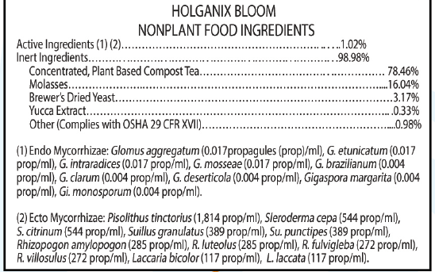

Nutrient analysis of Holganix.

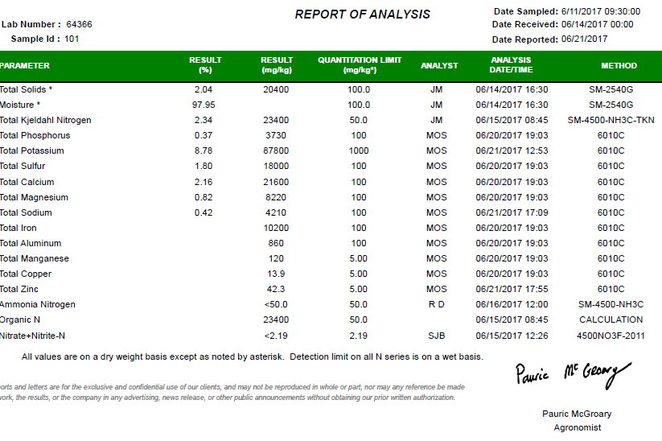

Fertilizer: Plantex 20-10-20

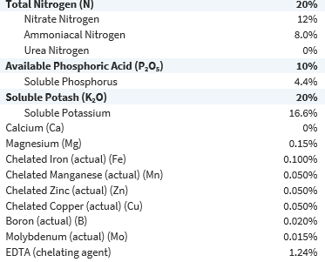

Fertilizer Plantex 15-0-15



Study began in Week 26 (June 28) and completed Week 34 (August 23). We used weekly 20-10-20 and 15-0-15 fertilization schedule to maintain EC at (1.5 first two weeks and 2.0 next 6 weeks) *Pour Through Method* and PH of 6.0. We drenched plants using 50oz of Holganix stock solution per 100 gal. of water. We drenched plant red and blue group once in week 26 and the blue group in week 30. Plants were irrigated as needed.

To measure as hypothesized the response of plant in height, branching and biomass, each plant (green/red/blue) was recorded biweekly in height/#of branches and took average for that group. In week 30 and 34 we measured the biomass weight of two specimens from each plant group. We took the largest and smallest specimens from that group measured by height and averaged their biomass for the study biomass calculation.

*Results*

As hypothesized the application of the compost tea/mycorrhizae had a significant contribution to height, branching and biomass compared to the control that had no application. (See Figure 1,2,3) We found in the first four weeks of production (establishment) that the control outperformed the treatment groups. In the following weeks (growth stage) the treatment groups outperformed the control significantly. The representative gains between the two treatment groups was significant as it related to biomass and root development. We found no differences in bud initiation timing between groups. There were no signs of root or foliar disease among any of the mum groups.

Throughout the eight-week study between the control and the two drenches sample an increase of 26% in height, 35% branching and 44% in biomass. Between the control and the one drench sample an increase of 5% in height, 25% branching and 31% in biomass was found. In the two treatment groups there was a greater incidence of PH drift downward during study compared to control.

Figure 1. Liquid Compost/ Mycorrhizae Drench

(Green Control No treatment, Red One Treatment, Blue Two Treatments)



Figure 2.



Figure 3. Liquid Compost/ Mycorrhizae Drench

(Green Control, Red One Treatment, Blue Two Treatments)



*Discussion and Conclusions.*

Greenhouse production growers want to grow beautiful plants that will not only sell but do well in the landscape once planted. Growers are looking for (1) improved plant root development and plant growth (2) Increased quality and quantity of flowers/fruits (3) Improved nutrient and water intake (4) Increased resistance to stress, root disease and transplant shock. This initial study showed that the use of Compost Tea/Mycorrhizae as amendments to the growing schedule in the greenhouse environment can have positive benefits for plants like those found in studies from organic field growing environments. *See (Scotti, Liguori, Pane)*

The significant increases of 26% in height, 35% branching and 44% in biomass point to the efficiency in root development, nutrient efficiency and water uptake. In the second week height measurement (week 28) there was a surprising difference as the control was 1.7 inches higher than the two-treatment sample. This was reversed by (week 34) at the end of the study with the two-treatment sample 2.5 inches higher. This points to the idea that initially the plant goes through an adjustment in its nutrient signaling to support root development comparatively over shoot development. Noted was the comparative slowdown in the two-treatment growth sample compared to the one treatment sample in branching and height in Week 30 after compost tea/mycorrhizae application. Again, the plant seems to comparatively stall to support roots before taking off again in normal growth pattern. This idea is supported in week 30 as all three treatment groups are comparatively at the same place regarding branching and height yet in total biomass the red and blue treatment groups are establishing at a respective 60% and 90% greater dry weight than control.

As this study maintained two ingredients as additions/supplements (compost tea and mycorrhizae) the contribution of each separately would have to be studied. Also, the industrial fertilizers were applied on the same weekly constant feed bases for all groups in a 20-10-20 or 15-0-15 Nitrogen/Phosphorous/Potassium ratio. When measured across the eight weeks study the fertility levels remained surprisingly close (measured in EC) compared to the significant difference in plant growth between groups. This suggest that the minerals applied bound to the mix in pot the same yet more are taken up by treatment groups rather than being washed out of pot during irrigation. In the two treatment groups there was a very slight incidence of PH drift downward that required adjustment using relative larger than expected amounts of 15-0-15 calcium based fertilizer to adjust PH upward.

During the study there were no problems related to stress/ disease or insect pressure in any of the groups. A comparative study across many seasons with varying and more challenging climate

scenarios then the 2017 summer would have to be studied. With the significant increase in root formation in the supplemented treatment groups it would be interesting to compare the relative drought tolerance in further studies. As only one crop was studied (Chrysanthemums) it will be necessary to evaluate the response of other greenhouse crops to these applications. Further studies should consider comparative reductions in industrial fertilizers while holding constant compost tea/mycorrhizae applications. This study showed initial possibilities for ornamental or vegetable greenhouse container plant production using liquid compost and mycorrhizae. Additional trials with other crops should be evaluated.

*References*

Scotti, R. (2015). Organic amendments as sustainable tool to recovery fertility in intensive agriculture systems. *Journal of soil science and plant nutrition,* *Vol15 no2*. <http://dx.doi.org/10.4067/S0718-95162015005000031>

Liguori, L., Pane, C., Albanese, D., Celano, G., Zaccardelli, M., & Matteo, M. D. (2015). Compost and Compost Tea Management of Mini Watermelon Cultivations Affects the Chemical,

Amaranthus, M. (2012). Tiny Soil Organisms Provide Big Soil Health Benefits. *Making the Most of Microbes,* *42*(10). Retrieved December 31, 2017. <http://mycorrhizae.com/wp-content/uploads/2013/03/Making-the-Most-of-Microbes-PDF.pdf>

Racsko, B. J., & Poole, H. (2017, December 05). How Mycorrhizae Provide Value at Your Greenhouse or Nursery. Retrieved December 31, 2017, from <http://www.greenhousegrower.com/production/media/how-mycorrhizae-provide-value-at-your-greenhouse-or-nursery/>

Pane, C., Palese, A. M., Celano, G., & Zaccardelli, M. (n.d.). Effects of compost tea treatments on productivity of lettuce and kohlrabi systems under organic cropping management. Retrieved December 31, 2017, from <http://www.agronomy.it/index.php/agro/article/view/ija.2014.596>

University of California, Division of Agriculture and Natural Resources. (n.d.). The Effects of Mycorrhizal Fungi Inoculum on Vegetables. Retrieved December 31, 2017, from <http://smsf-mastergardeners.ucanr.edu/Elkus/The_Effects_of_Mycorrhizal_Fungi_Inoculum_on_Vegetables>

*Acknowledgements*

We would like to thank our FFA Advisor Mr. Jerry Kelley for his direction, suggestions and support with this study.