*Abstract*

GROWTH RESPONSE OF CHRYSANTHEMUM (MORIFOLIUM) TO CONTAINER WALLS AND RESERVOIR.

A. Tribeck, Z. Bradley- Parkside High CTE, Wicomico Maryland FFA

Greenhouse growers are continually reaching for optimum plant development within the environment of soilless media plant containers. Growers/Retailers maximize related production spacing and container costs by matching the container to the rooting volume requirements at finishing time and end user need. Plant container root system hindrance such as spiraling on interior walls or girdling (choking) right below the plant substrate line can diminish the health of the plant.

An important consideration in plant container production is the design of the containers used. This eight-week study trialed the effectiveness of using interior pot partitions and water holding reservoirs. The study hypothesized that the partitions would prevent root spiraling and the reservoirs providing additional moisture when needed for the partitioned pot segments.

The addition of the partitions and reservoirs showed modest gains in shoot growth and significant gains in root development compared to control. Improved root development would pay dividends in transplant and drought tolerance.

*Introduction*

An important consideration in plant container production is the design of the containers used. The design effects plant growth characteristics, particularly the quality of the root systems. Plant container root system hindrance such as spiraling on interior walls or girdling (choking) right below the plant substrate line can diminish the health of the plant. Greenhouse growers are continually reaching for optimum plant development within the environment of soilless media plant containers. Growers/Retailers maximize related production spacing and container costs by matching the container to the rooting volume requirements at finishing time and end user need.

The industry standard for Chrysanthemum container production is a smooth walled, circular container, 8” width, 6” height, and drainage holes. Recent improvements in chrysanthemum nutrient and substrate amendment protocols has produced increases in root/foliar biomass.(Valentin)(Pusey) Chrysanthemum production from transplant into containers and thence flowering to purchase is 13-15 weeks. Of note in the two studies cited above , was a compaction of fibrous roots spiraling pot in last four weeks of production. This compaction compressed the substrate, diminished the water holding capacity and also channeled applied moisture/ nutrients directly to drainage at bottom of the pot.

The decision to be considered is to increase the size of the pot or change the pot characteristics. With limited display area the decision was made to study changes to current pot characteristics by improving root distribution. A recent research project in container vegetable production using internal vertical walls that increased the internal container surface area showed promise. One constraint considered in the use of internal vertical walls was the equal distribution of moisture/nutrients in the divided quadrants. In the study we used a plastic reservoir in two of the study considerations. Moisture and nutrients were applied using a drip irrigation system.

*Literature Review*

If the mechanical resistance of the soil or the container is not limiting, root trajectories follow smooth streamlines downward. When roots are deflected i.e. bottom or sides of pot, root expansion is limited even if root elongation is not. (Lx Dupuy 2018) When roots confront a barrier they twist and spiral enabling them to push off and generate larger force to their root tip. This allows the plant greater access to moisture and nutrients. The spiraling of roots surrounding the non-penetrable pot is similar to a spring coiling in a helix. (Plant Root 2020)

Multiple studies indicate that the size, volume, shape, depth, color, and even roughness of a container’s internal walls affect the growth characteristics of plants, particularly the quality of their root system. Various studies on the geometry of a container (from narrow and tall containers to wide and short containers) found that shape does not affect yield when the containers are of identical volume.  However, when a plant is in a container for a long period, the depth of the container determines the length of the plant’s main root and therefore the plant’s health and survival under limiting conditions.

. “Walls inside containers not only reinforce a container or pot from a mechanical perspective but also deter root spiraling. In addition to decreasing root deformation and better anchoring of roots, inner walls favor the production of biomass and root weight , which increases a plant’s ability to cope with drought stress and potential posttransplant stress.” (Gallegos p. 792 2020)

When it comes to choosing an appropriate container much depends on the specific plant being cultivated. “Container selection should therefore be in accordance with the characteristics that are specific to 1) the root system (2) the duration of the intended container culture and 3) the combination of the culture medium with its fertigation.” (Gallegos p.787)

*Materials and Methods*

We used forty chrysanthemums (Chelsey Yellow Plugs) and planted them in 8” mum pans on raised benches using drip lines for irrigation. We randomized the setting of 10 Mums as the control (Red) , 10

Mums with polycarbonate walls (Blue), 10 Mums with pan bottom reservoir (yellow), 10 mums with both

polycarbonate walls and pan bottom reservoir (Green)

Study began in week 26 (June 25) and completed Week 34 (August 21).

All plants are placed outside and attached to drip irrigation starting in Week 26. Plants receive 20/10/20 or 15/0/15 fertilization weekly. For all plants, the target EC is 1.5 during rooting, 2.0 during growth and 1.0 toward finishing. The PH is maintained at 6.0-6.2. All plants receive drench in week 27 with compost tea/ mycorrhizae. Plants are irrigated as needed.

For each plant group, recorded height and number of branches is taken every two weeks. Week 26, 28, 30, 32,34. One plant from each group is taken in week 30 and 34 and measured dry wight is recorded.

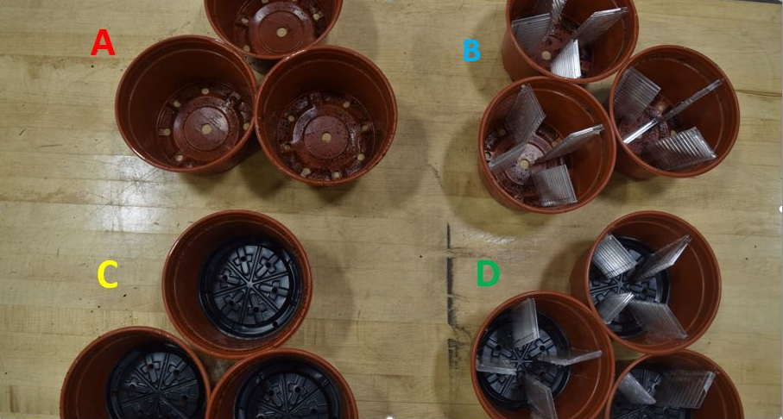

**Fertilizer: Plantex 20-10-20**



**Fertilizer Plantex 15-0-15**



*Results*

The addition of interior walls and reservoir have shown gains related to height, branching and biomass compared to control. The most notable gains in biomass were in the groups that had the addition of the reservoir. As mums have high levels of transpiration a comparative more readily available moisture source is from this study beneficial. The groups that had partition added showed larger mass of root structures. As the study proceeded into week 4 there were not significant differences in height and branching of all groups. As study progressed to week eight the most significant gains in reservoir and partition addition groups compared to control was in the biomass.

*Discussion and Conclusions*

Greenhouse production growers want to grow beautiful plants that will not only sell but do well in the landscape once planted. Growers are looking for (1) improved plant root development and plant growth, (2) increased quality and quantity of flowers/fruits, (3) improved nutrient and water intake, (4) increased resistance to stress, root disease and transplant shock. This study showed that the use of pot partitions and water reservoirs can have positive benefits for the development of plants in the container production setting.

The significant group increases relative to control were in the two groups that had additions of reservoirs.

These increases were reflected in the total biomass and root structure of plants. (6.1/6.6) control (4.8).

There were some minimal gains in height and branching of mums in both the partition and reservoir groups compared to control. Having a significant development of root structure would pay dividends for the long-term development of plant related to drought tolerance.

As growers are concerned about production costs related to pot costs/benefits we believe the addition of reservoir in mums should be considered first. The use of reservoir could protect crop from stress during particularly hot or windy periods. Further study might consider the use of partitions in larger planting pots that are not used for in ground planting.

During the study there were no problems related to stress/disease or insect pressure for any of the groups. A comparative study of different crops/ different root structures should be evaluated.

Gallegos, J., Álvaro, J. E., & Urrestarazu, M. (2020). Container Design Affects Shoot and Root Growth of Vegetable Plant. *HortScience,* *55*(6), 787-794. doi:10.21273/hortsci14954-20

Lx Dupuy, M Mimault, D Patko, V Ladmiral, B. Ameduri, et al.. Micromechanics of root development in

soil. Current Opinion in Genetics and Development, Elsevier, 2018, 51, pp.18 - 25.

ff10.1016/j.gde.2018.03.007ff. ffhal-01898743

Plant Root Spiraling Mechanisms: Ability to Bore Through Earth's Toughest Soil Structure. (n.d.). Retrieved July 03, 2020, from <http://creating-a-new-earth.blogspot.com/p/plant-root-spiraling-mechanisms-ability.html>

Pusey, K., & Ennis, L. (n.d.). 2019 Mum Study Biochar. Retrieved July 03, 2020, from http://aplusgardencentre.weebly.com/2019-mum-study-biochar.html

Valentin, O., & Heater, A. (n.d.). Compost Tea/ Mycorrhizae. Retrieved July 03, 2020, from <http://aplusgardencentre.weebly.com/compost-tea-mycorrhizae.html>