Abstract
EFFECTS OF MYCORRHIZAL INOCULATION ON PEPPER PLANT GERMINATION AND SEEDLING ESTABLISHMENT.
C. Messler , C. Hill Parkside High CTE, Wicomico Maryland FFA

There have been enormous amounts of studies related to the positive impacts of using the fungi endomycorrhiza in organic crop and turf management. These studies have shown that endomycorrhiza provides protection against pathogens and stimulates productivity of crops. However, there has been both few studies or adoption in the greenhouse transplant production setting that tests mycorrhizal efficiency related to vegetable plant seed germination, emergance and seedling establishment. Compared to other vegetables, peppers have one of the lowest seed germination rates and one the highest incidence rates of post emergent damping off. Improvement in pepper germination rates and seedling strength would provide time savings, stronger plants and improve profitably for this important commercial crop.

This study used an initial fungi priming seed soak or incorporated mycorrhizae in seed bed on pre-emergent pepper seed/plants. The study hypothesized that the inoculation of the seeds would improve germination/emergence, decrease damping off and improve biomass of seedling stand compared to control. Measurements conducted were plant emergence/ survival, root length, and height. Uniform rates of irrigation, fungicide treatment and fertilization were maintained for all three tested replicate groups.

Introduction
A typical vegetable transplant greenhouse environment may grow numerous crops and cultivars of plants at any one time depending upon market demand and the ability of employees to care for a diverse range of plant requirements. Seed produced plants are susceptible to stresses due to the limited root space, soilless substrate and dependency on irrigation. Finding a perfect balance between the media in the propagation trays or subsequent transplant pots and all the varying plant culture requirements is challenging. The first order in this process is getting plant seed to germinate, rooted and established for transplant. Compared to other vegetable crops pepper plants are relatively problematic in their lower germination rates and susceptibility to damping off after emergence. Pepper seedlings with their shallow roots, nutrient needs and needed protocols against disease pressure require particular care in getting plants established for transplant.

This study used mycorrhiza as a priming seed soak or incorporated seed bed layer in comparison to a typical pepper establishment protocol. This study replicated positive results found in studies associated with tomatoes, peppers and radishes using mycorrhiza in the organic garden setting. It is hypothesized that the mycorrhiza will add efficiency to the immediate breakdown of critical nutrient elements as plants emerge from seed, provide larger root network to absorb those nutrients and develop stronger plants to withstand disease pressure.

Literature review

Mycorrhiza refers to a group of fungi which form a symbiotic relationship with the plant roots. Most plants convert forty percent or more of their energy produced by photosynthesis into roots that feed and stimulate these fungi and soil microbes. (Amaranthus) Plants in natural systems provide the sugars needed for these microbes that decompose organic matter that promotes soil health. Mycorrhiza fungi grow through the soil as fine hair-like strands called hyphae. These strands form a network to absorb water and minerals for the soil and then transport back to the roots. Research has shown that mycorrhizae are especially important in making important minerals more soluble and available to plants. On their own, plant roots can only absorb a small volume of nutrients before they hit their depletion zone around their roots. This depletion zone is particularly important for immobile nutrients such as phosphorus. Mycorrhiza overcome this by increasing the absorption area of plant roots by up to fifty times. (Racsko) Additionally, these fungi secrete organic acid that dissolves ions or releases them by ion exchange that convert them into bioavailable forms.

Most of the soilless mixes used by container growers are a mixture of bark, peat, perlite and vermiculite. Most container mixes start with a starter charge of synthetic fertilizer to provide the initial nutrients needed for container plants. With the introduction of soluble and deliverable microbes, growers can add biology to the pot so to speak in a uniform and consistent program of delivery. Cropping methods using mycorrhiza fungi have found significant positive yields. A lettuce and kohlrabi study found plant weights to increase by approximately twenty to thirty percent. (Pane) A study found using mycorrhizal fungi inoculum on vegetables found they grew taller and more disease resistant. (University of California)

Endomycorrhiza treatments in tomato seedlings have found improved plant vigor in juxtaposition to induced plant stressors. (Basak) One study growing pepper plants in soilless substrate and inoculated with mycorrhiza at time of seed sowing or field transplant showed increased vigor in regard to dry weight. (Ikiz) A study looking at the effects of seed priming with mycorrhizae and seed germination showed reduced times for radishes to germinate. (Gutowski)

Materials and Methods

Environment: Study was conducted in Jan/Feb in Garden Centre Greenhouse Zone 7B with 70degree ambient temperature benches with heat mats 85 degree.

Study Seed: Pepper (Bell) Yankee Bell purchased from Johnny’s seed.

Germination trays/ mix: 1”x1” cell size 288 trays/ commercial fine germination mix

Mycorrhiza: MycoApply (T) Suspendable Power 130,000 Endomycorrhizal Propagules per lb.
Glomus intraradices, Glomus mosseae, Glomus aggregatum, Glomus etunicatum

Study will have three test samples with three replicates.

Test study sample trays X3

(1) Control- (Seed stratified 2 weeks), (presoaked H20- 8 hours). (40 seeds placed in cells), placed on germination mat.
(2) M1- (Seed stratified 2 weeks), (Presoaked mycorrhiza 2oz/per gallon 8 hours), (40 seeds placed in cells), Placed on germination mat.
(3) M2-- (Seed stratified 2 weeks), (presoaked H20- 8 hours). (Seedbed germination mix incorporated mycorrhiza 1lb./ per yd3), (50 seeds placed in cells)

Measurements

(1) % Emergence/ Survival 15 days, 30 days, 45 days – Avg. from 3 Replicates
(2) Plant Height 15 days , 30 days, 45 days- Avg. from 3 Replicates
(3) Root Length (Dry)(20 plants). 15 days, 30days, 45 days – Avg. from 3 Replicates

Seed Beds maintained equal moisture throughout study.

Results

As hypothesized the application of the mycorrhiza had significant contribution to root formation and height. The results show that there was minimal improvement in germination rate/survival and no significant difference in emergent time. The results do show that the mycorrhiza improved survival post emergence.
After 45 days there was significant increase in root density and plant vigor of the soaked mycorrhizae seed /plants compared to control. The seed-soaked mycorrhiza improved 50% in root length and almost 30% in height. The incorporated mycorrhiza improved over the control as well. The incorporated mycorrhizae improved root length by 25% and height by 20%. Of note was the slow start after 15 days of the mycorrhizae treated plants.

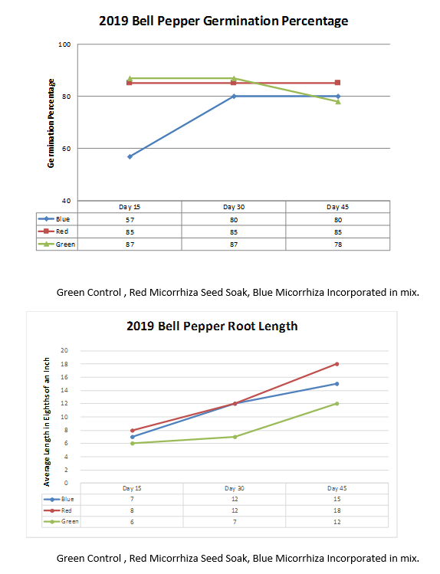
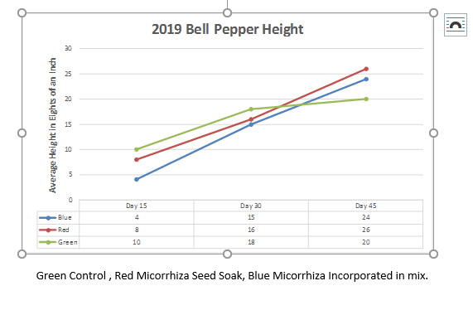

Discussion and Conclusions:

Improving germination rates, survival of seedlings and development of healthy transplants during vegetable plant production can make for significant contributions toward profit and time savings for growers. This study showed significant gains by using endo-mycorrhiza as a preparatory seed treatment during pepper seed germination.

There was no significant gains in either emergent times or germination rates. However, there was significant gains in root and shoot development. The improved density of root formation would improve transplant readiness and survivability due to varying stressors during that time.
( Between day 30 and 45 there was damping off which occurred for control) This improvement using mycorrhizae should be studied and replicated using other seed groups.

References:

Amaranthus, M. (2012). Tiny Soil Organisms Provide Big Soil Health Benefits. Making the Most of Microbes, 42(10). Retrieved December 31, 2017. http://mycorrhizae.com/wp-content/uploads/2013/03/Making-the-Most-of-Microbes-PDF.pdf
Basak, H. (2011). Technology Education-Process or Content. African Journal of Agriculture Research,6(11), 2532-2538. Retrieved December 26, 2018, from http://www.researchgate.net/publication/228820026_The_effect_of_endo-mycorrhiza_VAM_treatment_on_growth_of_tomato_seedling_grown_under_saline_conditions.
Gutowski, V. (2015). The effect of mycorrhizae on seed germination, development, and reproductive yield of Rapid Gro Radish. ESSAI,13, 18th ser. Retrieved December 26, 2018.
https://dc.cod.edu/cgi/viewcontent.cgi?referer=http://www.google.com/url?sa=t&rct=j&q=&esrc=s&source=web&cd=1&ved=2ahUKEwic46m4jr7fAhWStlkKHeYWChkQFjAAegQICRAC&url=http%3A%2F%2Fdc.cod.edu%2Fcgi%2Fviewcontent.cgi%3Farticle%3D1533%26context%3Dessai&usg=AOvVaw2hrhDBW9aKVMIVuFFrz-i&httpsredir=1&article=1533&context=essai

Ikiz, O., Abak, K., Daşgan, H., & Ortaş, I. (2009). Effects of Mycorrhizal Inoculation In Soilless Culture On Pepper Plant Growth. Acta Horticulturae,(807), 533-540. doi:10.17660/actahortic.2009.807.78.
https://www.researchgate.net/publication/286257529_Effects_of_mycorrhizal_inoculation_in_soilless_culture_on_pepper_plant_growth

Pane, C., Palese, A. M., Celano, G., & Zaccardelli, M. (n.d.). Effects of compost tea treatments on productivity of lettuce and kohlrabi systems under organic cropping management. Retrieved December 31, 2017, from http://www.agronomy.it/index.php/agro/article/view/ija.2014.596
Racsko, B. J., & Poole, H. (2017, December 05). How Mycorrhizae Provide Value at Your Greenhouse or Nursery. Retrieved December 31, 2017. http://www.greenhousegrower.com/production/media/how-mycorrhizae-provide-value-at-your-greenhouse-or-nursery/

