PLANT BIOSTIMULATION: MICROALGEA (SPIRULINA) SEED SOAK AS A SUSTAINABLE MEANS TO IMPROVE WILDFLOWER SEEDLING DEVELOPMENT.
Kayla Matthews, Jasmine Tribeck Environmental Services/Natural Resource Systems Division 4
Parkside High CTE Horticulture, FFA Wicomico, Maryland
There have been numerous studies related to the positive impacts of using microalgae as a plant biostimulant in agriculture. Microalgae have proven to deliver quicker growth rates and increased biomass without the harmful effects on the environment of chemical inputs. However, there has been both few studies and literature on the adoption of using microalgae in the establishment of wildflowers and improving habitat.
This 20-day study used an initial Spirulina plantensis (microalgae) filtrate and homogenate as a priming seed soak for Echinacea purpurea. The study hypothesized that the inoculation of the seeds would improve germination/emergence, decrease damping off and improve biomass of seedling stand compared to control. Measurements conducted were , root to shoot length, root branching, and true leaf development.
Wildflower seedling emergence is significantly promoted with the prior seed soaking in Spirulina plantensis in both the filtrate and homogenate groups. Echinacea seeds soaked for six hours in the homogenate group had larger leaf development, development of true leaves, gains in root to shoot, and root branching among all groups.
Introduction
The benefits of wildflower plantings are many. Depending on the wildflower site, economical, educational, recreational, ecological, and aesthetic advantages may exist. There are several ecological benefits of a wildflower meadows. Wildflowers can improve water quality by decreasing amounts of runoff of pesticides, petroleum products, lead, and sediments. Increased water quality and reduction in air pollution can be realized compared to turf areas because of the wildflower plant’s ability to trap and hold pollutants related to its increased vegetative biomass. Once trapped, pollutants are not able to runoff as pollution to the groundwater, thereby improving water quality. Wildflowers anchor soil with deep dense rooting to stabilize eroding slopes, river or stream banks, and beach dunes. Wildflower plantings use little, if any, pesticides thereby the potential for offsite movement of pesticides is decreased. Wildflower meadows can act as greenways, with wildlife using them for food, shelter, and transportation corridors. Wildflower plantings aid in habitat restoration and protection by attracting birds and insects, especially butterflies. From an educational and recreational standpoint, wildflower plantings afford people the opportunity to observe, interact, appreciate, and understand more about natural settings. Native wildflowers store significant amounts more carbon than turf grass which has much shorter roots and thus stores much less carbon. Specifically, Echinacea attracts many insects, such as honeybees and small songbirds, because of its nectar and seeds. It grows anywhere from two to four feet tall and is tolerant of poor soil conditions, drought, and extreme heat conditions.
Developing strong wildflower meadow areas can be difficult and inhibited by week seed germination and root development. Without a dense and somewhat rapid development of plants, weeds can take over seed plots almost immediately. Likewise, harsh, and unexpected weather conditions can put newly seeded wildflower plots at stress. Stimulating stronger and faster wildflower rooting outcomes would improve wildflower establishment.
Conventional agriculture has relied for the most part on non-renewable inputs of fertilizers and pesticides. Plant biostimulants can play a large part role in addressing sustainability challenges by reducing total dependency on fertilizers and by improving crop yields and plant stability under environmental stresses. Microalgae derived products have shown to improve seed germination, nutrient uptake, shoot and root development and crop performance. Studies have indicated that specifically, Spirulina platensis, has shown remarkable results as a seed inoculation and foliar application both in leafy and fruit vegetables.
Literature Review
The study below using microalgae as a both a seed primer and foliar spray resulted in significant gains in tomato plant seed germination, plant development, and fruit production.
Our study showed that the application of live A. dimorphus culture and aqueous cell extracts increased seed germination percentage in all treatments compared to the control group. This study demonstrated that the application of A. dimorphus aqueous extracts, live culture, and dry biomass enhanced the germination, growth, and potential yield of tomato plants. Our study showed that the application of live A. dimorphus culture and aqueous cell extracts increased seed germination percentage in all treatments compared to the control group. The seeds treated with live A. dimorphus culture germinated faster, meaning the seedlings had the greatest vigor. El Arroussi, et al., 2018, p. 1060.
The below study of rice seeds were treated with extracts of the microalgae Phormium species before sowing. The study reflected that the algal hormone in the extract markedly promoted growth and development of both the roots and shoots of the rice seedlings.
The data show that the height of the plant, the number of tillers, the number of leaves, the length and the breadth of leaves increased considerably following treatment with 5 per cent water extract as compared with the control. The beneficial effect was maintained throughout the duration of the crop. Ether extract suspended in water also exercised a beneficial effect on vegetative growth of plants. The maximum increase in height of plants and length of leaves was observed in plants treated with 1 per cent algal extract, while number of leaves, breadth of leaves and numbers of tillers was markedly better in 5 per cent ether extract. (Shukla AC, Gupta AB,1967, p. 744)
The study below used the microalgae Spirulina plantensis as a priming seed and foliar biofertilizer that enhanced growth in the high protein legume crop Lupinus luteus ( Lupine)
This study proved that the priming or spraying of L. luteus with S. platensis extract increased growth indices, yield measurements, photosynthetic pigment content and capacity. This improvement was linked to the biologically active compounds generated by S. platensis such as phytohormones (elicitor molecules). Phytohormones participate in signaling pathways that promote plant development and productivity. Furthermore, the elevation of macronutrients such as K+ and Mg+2 in L. luteus leaves may have a role in increasing the photosynthetic rate and hence growth and yield. The spraying procedure had superior effect than the priming treatment on all assessed criteria. In contrast, a greater concentration of S. platensis had a suppressive effect on growth, yield, and photosynthetic characteristics. (Shedeed ZA, et. Al, 2022, p.12)
Spirulina is considered a cyanobacteria. Cyanobacteria are aquatic and photosynthetic, that is, they live in the water, and can manufacture their own food. Because they are bacteria, they are quite small and usually unicellular, though they often grow in colonies large enough to see. The paragraph below outlines the multiple pathways that spirulina can enhance positive plant responses.
The naturally effective molecules that produced by cyanobacteria, including phenolics, proteins, vitamins, carbohydrates, amino acids, polysaccharides and phytohormones, may work out in cooperation to enhance plant growth. Cyanobacteria are involved in the signaling pathway of gene expression for plant metabolism regulation. Moreover, cyanobacteria improve the rhizosphere community, leading to the modulation of the root system and mineral nutrition. Cyanobacterial extracts can be used to improve seed germination, plant growth, flowering, and fruit production, as well as the life shelf of post harvested fruits. By improving mineral nutrient utilization. Microalgal/cyanobacterial metabolites can stimulate a variety of plant metabolic responses, including respiration, photosynthesis, nucleic acid synthesis, chlorophyll formation and ion absorption. Cyanobacteria can reduce stressors through crop management. (Shedeed ZA, et. al, 2022, p.2)
Material and Methods
Parkside FFA horticulture class cultivated Spirulina in two-week period before the study date. Using a provided spirulina rinsate the microalgae spirulina homogenate was formed in production.
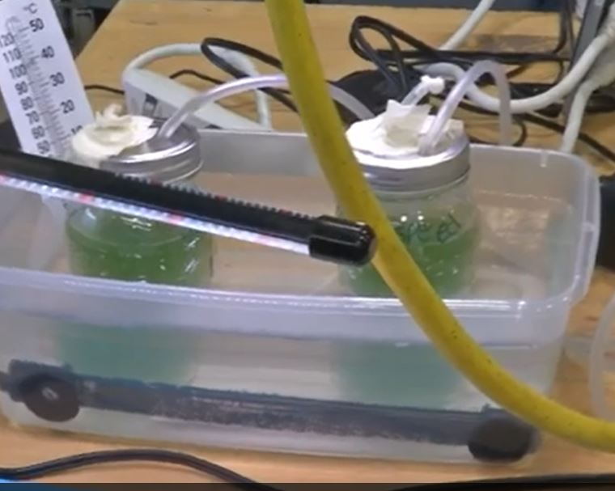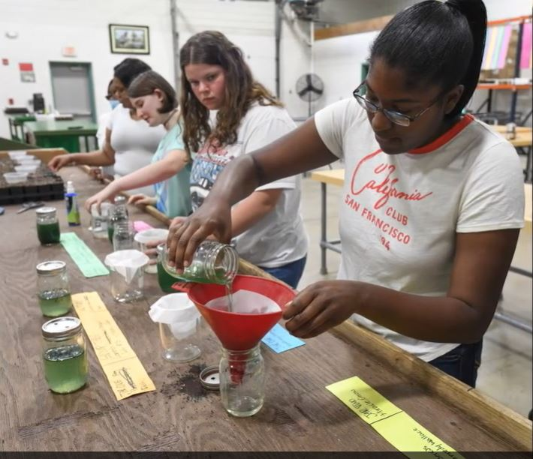

Seed trays of bark/peat based potting mix were set up with 60 seeds of Echinacea purpurea allotted for 7 evenly divided areas each area containing 12 cells. (See below.) Control seeds were soaked in distilled water. The two other study groups moistened for priming in wet paper towels saturated with either the Spirulina rinsate or the Spirulina homogenate. Seeds were saturated in the rinsate and homogenate for 6 hours, 12 hours, and 24 hours before planting.
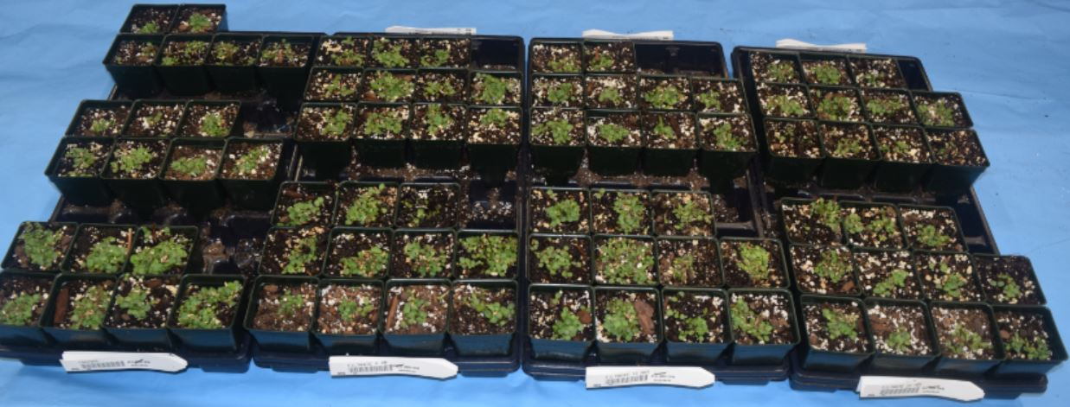

Homogenate

Rinsate

Control 6hr Seed Soak 12hr Seed Soak 24hr Seed Soak
Seeds in each tray were placed in greenhouse and given the same treatment regarding temperature and moisture. No fertilizer or organic amendments were added during the study period. After 10 days 6 of the cells from each of the seven groups were pulled for observation and measurements. Plants were carefully extracted from each study group and the most vigorous were pulled for group comparison. After 20 days the remaining 6 cells of each study group were pulled, and the plants with the most vigor again extracted for comparison.
Measurements
Plants were measured for average root to shoot length and average number of root strands. The development of cotyledons and true leaves were also observed. (See below)
10 Days Fiqure 1.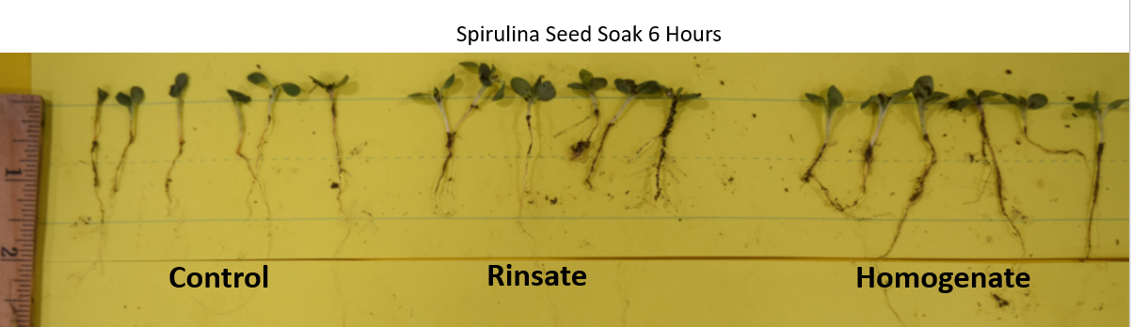
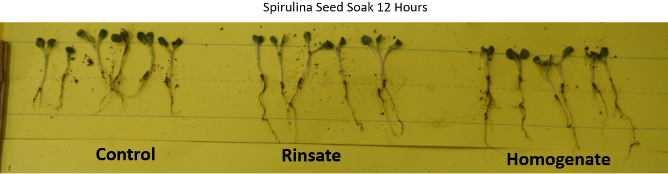
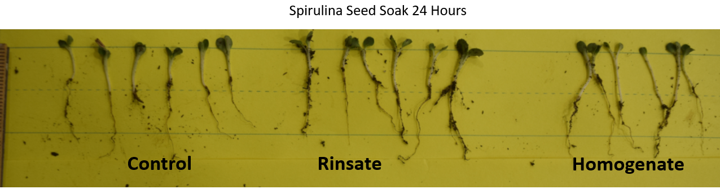

20 Days Fiqure 2.
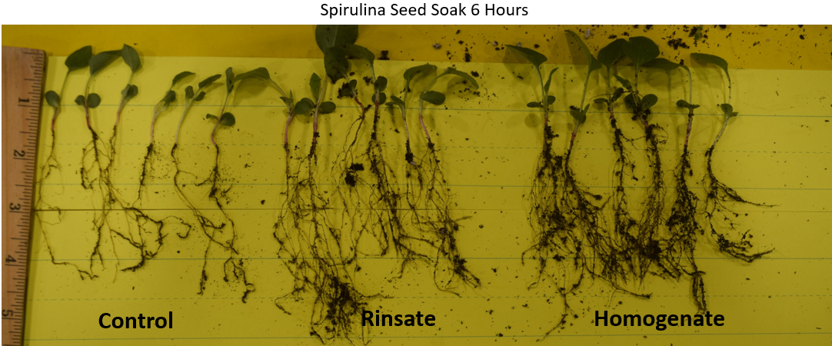
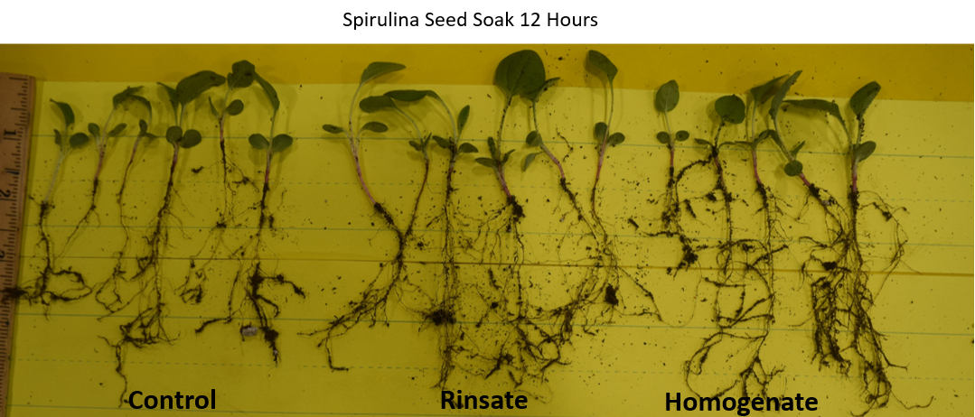
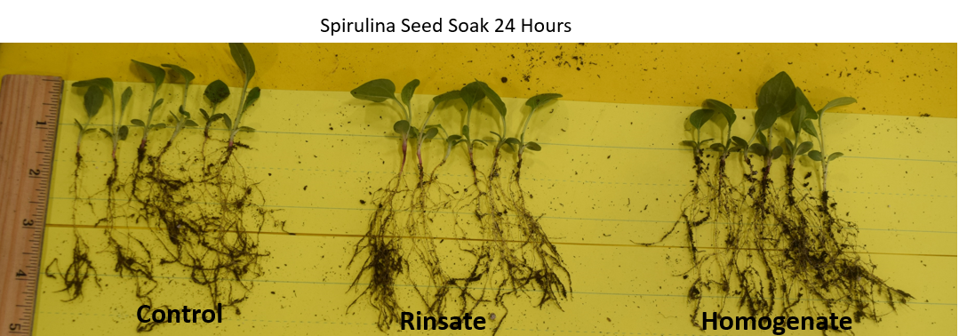
Results
Table 1: Root Shoot Development 20 Days
 | 6 Hr. Soak | 12 Hr. Soak | 24 Hr. Soak
Control Root to Shoot” | 4.5 | 4.5 | 4.5
Control Root Strands # | 3 | 2 | 2
Control Cotyledons Y/N | Y | Y | Y
Control True Leave # | 1 | 1.5 | 1
Rinsate Root to Shoot” | 5.0 | 5.0 | 4.5
Rinsate Root Strands # | 3 | 2 | 3
Rinsate Cotyledons Y/N | Y | Y | Y
Rinsate True Leave # | 2 | 1 | 1
Homogenate Root to Shoot” | 5.5 | 5.0 | 5.0
Homogenate Root Strands # | 5 | 4 | 4
Homogenate Cotyledons Y/N | Y | Y | Y
Homogenate True Leave # | 2 | 1 | 1

10 days
- Seeds soaked for 6 hours showed increased growth over others. Longer the soaking less gain.
- Rinsate group had larger cotyledon development and root branching development over control.
- Homogenate group had larger cotyledon development, development of true leaves, gains in root to shoot, and root branching among all groups.
- No observed difference in leave emergence and germination rates among groups.
20 days
A. Seeds soaked for 6 hours continue to show increased growth over others.
B. Rinsate group significantly outperformed control in root to shoot length, first leave development, root length, root mass.
C. Homogenate group had larger leaf development, development of true leaves, gains in root to shoot, and root branching among all groups. Larger biomass of plant development.
D. No observed damping off during first 10 or 20 days in any of groups.
Discussion and Conclusion.
The early establishment of wildflower/meadow sites can be promoted with the use of an algae-based seed priming agent before sowing. The biostimulation of seeds can greatly increase the effective rooting of plants, thereby enhancing subsequent plant growth and tolerance of environmental extremes. The early establishment of root strands can extend into the surrounding soil forming an essential link between the plant and soil resources. A strong stand of rooted and established wildflowers in the near-term weeks shortly following sowing and germination can suppress the encroachment of weeds. With a fall sowing of wildflower seeds the strong rooting provided by the algae fortified plants would make ready plants for spring takeoff.
There should be further research trials on presoaking of other types of wildflowers before seeding. It is possible that the 12 and 24 hours of presoaking of seeds limited the oxygen to the seeds and contributed to lack of vigor. It would be appropriate to study other forms of algae and their priming effects on wildflowers.

Acknowledgements
We would like to that our FFA Advisor Jerry Kelley for his support in organizing our approach to this study and helping with obtaining supplies. We would also like to thank our other chapter members with support in preparing the Spirulina hydrolysate and the support with the distribution of seeds.
References
El Arroussi, H., Benita, R., Elbaouchi, A., Sijilmassi, B., El Mernissi, N., Aafsar, A., et al. (2018). Dunaliella salina exopolysaccharides: a promising biostimulant for salt stress tolerance in tomato (Solanum lycopersicum). J. Appl. Phycol. 30, 2929–2941. doi: 10.1007/s10811-017-1382-1
Shedeed ZA, Gheda S, Elsanadily S, Alharbi K, Osman MEH. Spirulina platensis Biofertilization for Enhancing Growth, Photosynthetic Capacity and Yield of Lupinus luteus. Agriculture. 2022; 12(6):781. https://doi.org/10.3390/agriculture12060781
Shukla AC, Gupta AB (1967) Agriculture: influence of algal growth promoting substances on growth, yield, and protein contents of rice plants. Nature p. 744

