Wildflower Germination and Seedling Response to Smoke Priming
Madelyn Griffin , Adithya Bhaskaran
Environmental Services Natural Resources Division 4
Parkside High CTE Horticulture. FFA Wicomico Maryland
Abstract.
There have been numerous studies related to the positive impacts of smoke as an aid in germinating seeds. In many fire-prone ecosystems, species cue their germination to immediate postfire conditions. Smoke stimulated germination has been reported from a huge diversity of plant species.
There is clear evidence that there are both inorganic and organic chemicals generated or released by smoke that will stimulate germination of seeds. The insights gained in smoke aided germination could provide immeasurable benefits particularly in ecological restoration projects where successful germination and subsequent plant establishment are important.
This study’s focus was to quantify the feasibility of smoke enhanced germination on Rudbeckia Hirta. There had been some evidence that Rudbeckia seed germination is not enhanced measurably by smoke treatment. This study found that Rudbeckia seed germination is dramatically increased by smoke treatment when the seed is first soaked for six hours before smoke treatment applied.
Introduction
In an era marked by a growing emphasis on environmental awareness and sustainable practices, the act of wildflower planting emerges as a powerful embodiment of these values. Beyond its inherent visual appeal, wildflower planting offers a range of benefits—economic, educational, recreational, and ecological—depending on the specific planting location. This practice, commonly embraced in gardens, public spaces, and urban landscapes, represents a harmonious synergy between human intervention and the natural world. The diverse advantages of wildflower planting encompass its pivotal role in enhancing biodiversity, fostering healthier water quality, and promoting cleaner air by reducing the runoff of pollutants such as pesticides, petroleum products, lead, and sediments into water bodies. Comparisons to turf areas highlight how wildflowers, through their substantial vegetative biomass, efficiently trap and retain pollutants, resulting in improved water quality and reduced air pollution. These blossoms, with their deep and dense root systems, act as anchors, stabilizing eroding slopes, river/stream banks, and beach dunes. By attracting birds and insects—particularly butterflies—wildflower plantings further contribute to habitat restoration and protection.

The benefits of wildflower planting are closely aligned with the imperative for successful seed germination, creating a conducive environment for the delicate and pivotal initial stages of seed development. Effective seed germination methods are crucial for the utilization of seeds in conservation and restoration programs. Consequently, extensive research endeavors have been directed toward understanding novel strategies for breaking seed dormancy and encouraging germination. Despite considerable progress, unresolved seed germination requirements persist within certain plant families, posing challenges to large-scale seed-based propagation for restoration. The complexities of seed dormancy present a significant obstacle to the efficient use of native seeds in restoration efforts. Addressing these germination challenges involves leveraging existing knowledge, identifying gaps, and exploring new approaches within the realm of wildflowers.

In the intricate process of growth, the captivating phenomenon of seed germination is often instigated by environmental cues, and smoke emerges as a fascinating catalyst within specific ecosystems, notably wildflower environments. Fire serves as a major selective force in the environment, influencing plant communities across the globe. Evolution has shaped reproductive strategies as adaptations to the diverse factors associated with or generated by fires, particularly evident in seeds which have evolved to respond to both physical and chemical cues connected with fire events. Among these cues, karrikins—a family of closely related organic compounds produced during plant combustion—play a remarkable role in stimulating the germination of numerous plant species. Certain plants adapted to post-fire growth rely on dormant seeds that remain in the soil until fire-generated karrikins bind to soil particles. Once washed into the soil by rainfall, these karrikins trigger germination. Fire-derived smoke is harnessed in horticulture to prompt seed germination in wildflower species. Smoke can be applied just before sowing or through pretreatment of seeds, ensuring both smoke and aqueous smoke-water are effective triggers for germination.

Literature Review.
Karrikins are a family of compounds produced by wildfires. This background article summarizes recent research that identified these compounds that can stimulate the germination of dormant seeds of plants from numerous families.
Karrikins are a family of closely related small organic compounds that are produced when plant material burns. They are remarkable because they can stimulate the seeds of many plant species to germinate en masse. In particular, some plants that grow immediately after bushfires or wildfires have evolved such that their seeds remain dormant in the soil until a fire generates karrikins that are bound to soil particles. Then, once the karrikins are washed into the soil by rainfall, they stimulate the seeds to germinate. Some of these species will grow rapidly, flower, produce new seed and then die, usually after a year or two. The new seed that falls to the ground remains dormant until a future fire generates fresh karrikins to awaken them to grow and produce a new generation of seeds. (Flematti, et.al. 2015)
The following study evaluated the effects of smoke treatments derived from five plant species that are not fire-following species. The germination percentage and germination rate of four important horticultural crops—cucumber, tomato, gladiolus, and scotch marigold were assessed.
In this study, we chose smoke-waters that are easily obtainable and a technique that is convenient and inexpensive for farmers. The current study clearly shows that plant-derived smoke-water treatments, particularly the smoke-water derived from white willow and lemon eucalyptus effectively improved germination percentage and germination rate, and seedling growth of the tested crops. In accordance with our results, smoke-water and smoke-derived compounds have a positive effect on seed germination and the post-germination. (Elsadek, M.A, Yousef, E.A., 2019, p.6)

This summary study indicates that smoke can influence several growth-related processes in addition to improving germination percentage and germination. These additional benefits can support plant from germination through establishment and growth.
Plant-derived smoke was proven to be a promoting factor for several growth-related phenomena of plants including breaking seed dormancy, accelerating seed germination, and increasing seedling vigor. Biochemical parameters such as photosynthetic pigments, total nitrogen, total soluble proteins, and photosynthetic rates increased under plant-derived smoke treatments. Furthermore, a supply of plant-derived smoke solutions during flooding stress led to the flooding recovery of soybean after the removal of water . It reduced the inhibitory effects of heavy metal, drought, salinity, and high/low temperature stresses on plant growth. These results indicated that plant-derived smoke is a growth enhancer, reducer of inhibitory effect of environmental stresses, and a possible plant-growth fertilizer. (Khatoon, et.al., 2020, p.1)
Material and Methods
The beginning date for this study was 8/1/2023. Seeds for this study were obtained from American Meadows. The wildflower seed used. 1. Rudbeckia Hirta
4 Plant trays were filled with ProMix BK25 for study group. See below seed preparation.
Tray 1. Rudbeckia Control. 100 Seeds sown with light covering of mix.
Tray 2. Rudbeckia Soak. 100 Seeds soak in distilled water for 6Hr. Sown with light covering
Tray 3. Rudbeckia Smoke. 100 Seeds smoked for 20 min. Sown with light covering
Tray 4. Rudbeckia Soak and Smoke. 100 Seeds soak in distilled water for 6Hr. Seeds smoked for 20 min.
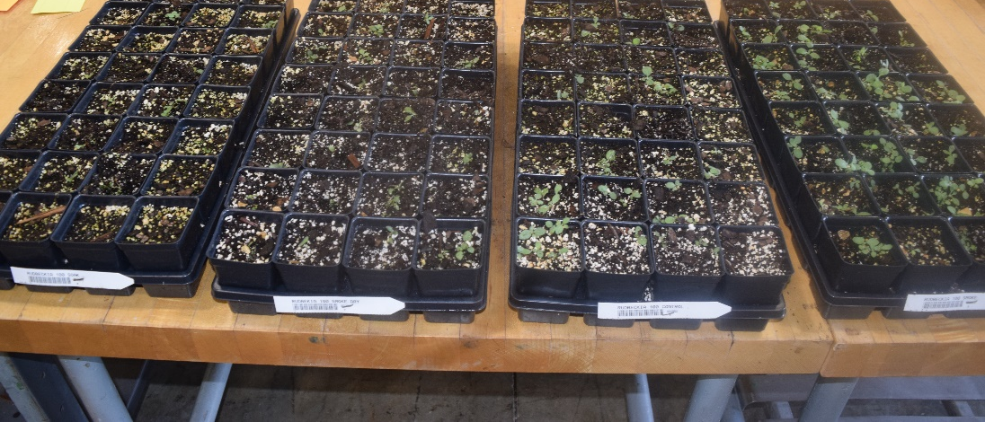

Smoke Process.
Square metal container was used for fire that was ignited with dried wildflower stems harvested from local meadow. Once the fire was diminished seeds were placed on metal grill for smoking for 20 minutes. Tea balls were used to hold seeds. Seed trays were placed in shade 50/50 greenhouse and lightly watered 2x each day.

Measurements.
Evaluation of germination rate was taken after 15 days.
Evaluation of root and shoot development taken after 20 days.
Germination Rate % 15 Days
Rudbeckia Control | 43
Rudbeckia Soak | 25
Rudbeckia Smoke | 50
Rudbeckia Soak/Smoke | 99
Table 1
Root Development 20 days
 | Root to Shoot “ | Root Strand # | Cotyledons Y/N | True Leaves Y/N
Rudbeckia Control | 2 | 3 | Y | Y
Rudbeckia  Soak | 1.5 | 2 | Y | Y
Rudbeckia Smoke | 1.75 | 3 | Y | Y
Rudbeckia Soak/Smoke | 2.5 | 4 | Y | Y
Table 2
Root Development. 20 days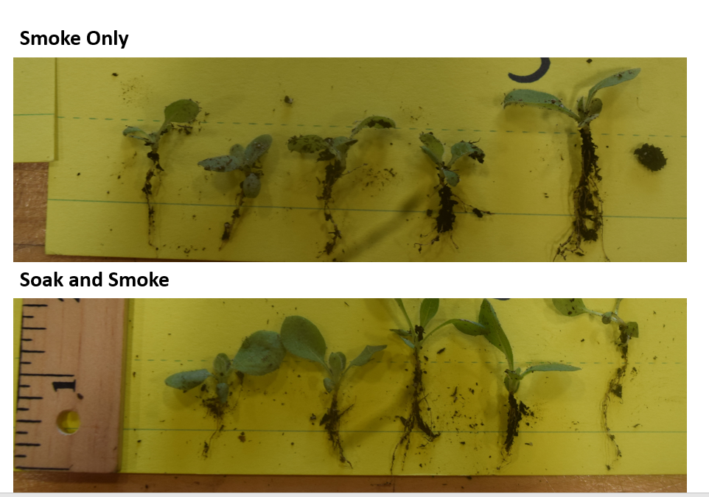
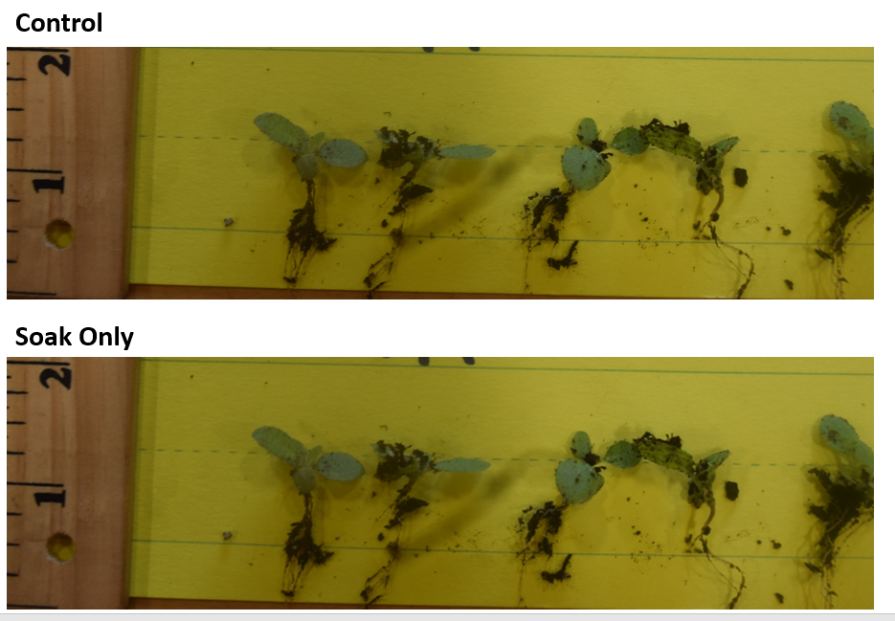

Discussion
Seed germination is a critical phase of the plant life cycle, influencing the distribution and abundance of species in plant communities. Biotic factors, intrinsic to the seed and/or interactions with other organisms and abiotic factors, such as light, temperature, humidity, and fire, affect germination differently. Fire can interfere in many aspects of plant development, especially in the biology of seeds. The effects of fire on seeds include loss of viability, and the activation of genes important to germination by the presence of smoke.
With the numerous factors contributing to seed germination, studies have shown mixed results in the improvement in Rudbeckia Hirta germination with smoke applications. This realization guided us to provide four study groupings to compare different applications that could enhance understanding.
Conclusion
Seed germination of Rudbeckia Hirta is significantly improved by priming seed with six-hour soak before smoke treatment. Seeds soaked and smoked outperformed those that were only smoked by nearly 50%. (Table 1.) Seeds soaked and smoked outperformed those that were only soaked by nearly 75%.
The combination of soaking seeds first and smoking seed subsequently is an important sequence for Rudbeckia Hirta. The soaking and smoke group also reflected significant gains after 20 days. in respect to root to shoot growth, and root development. (Table 2.) The significant germination increases, and root establishment rates provide evidence that priming seeds with soak and smoke can be valuable tool in wildflower establishment. It would be valuable to study other groups of wildflowers to ascertain germination success rates using these study protocols.
Acknowledgements
We would like to thank our advisor Mr. Jerry Kelley for supporting this research with ideas
related to protocols and measurement formats. We would like to thank our fellow chapter members who provided support with maintaining crop i.e., watering, and spacing.

References
Elsadek, M. A., & Yousef, E. A. A. (2019, April 18). Smoke-water enhances germination and seedling growth of four horticultural crops. Plants (Basel, Switzerland). https://www.ncbi.nlm.nih.gov/pmc/articles/PMC6524032/
Flematti, G. R., Dixon, K. W., & Smith, S. M. (2015, December 21). What are Karrikins and how were they “discovered” by plants? - BMC biology. BioMed Central. https://bmcbiol.biomedcentral.com/articles/10.1186/s12915-015-0219-0#Sec15
Khatoon, A., Rehman, S. U., Aslam, M. M., Jamil, M., & Komatsu, S. (2020, October 20). Plant-derived smoke affects biochemical mechanism on plant growth and seed germination. International journal of molecular sciences. https://www.ncbi.nlm.nih.gov/pmc/articles/PMC7588921/

