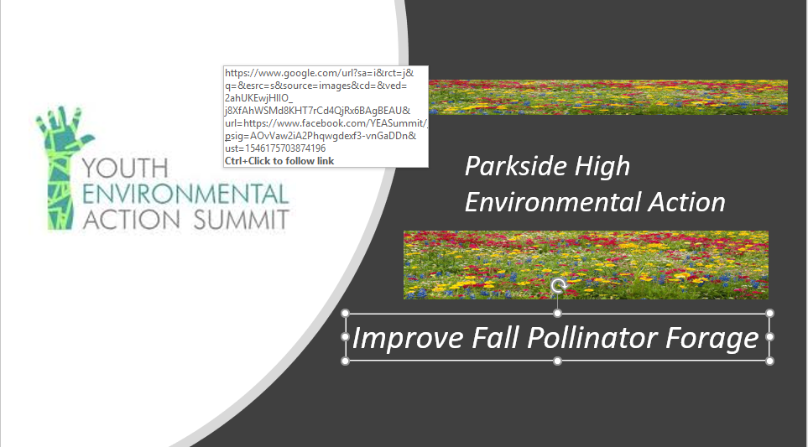

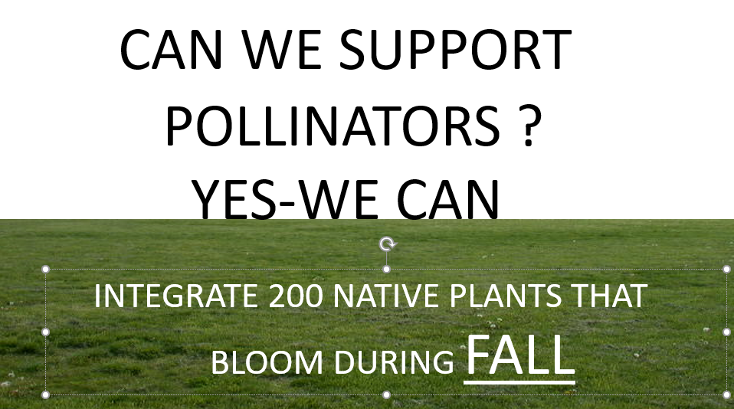

Summary:
The Parkside Horticulture 2020 Y.E.A.S project will focus on pollinator fall forage plants that are limited in the surrounding school area. One of the major reasons for dwindling pollinator populations is habitat loss. Additionally, the lack of a consistent food source contributes to these declines. A survey in the fall of 2019 recognized less than 20 plants on the Parkside High campus that would be considered late season abundant forage.

The plantings will be located in three areas of campus. The 200 native plants scheduled for planting in Sept. 2020 will consist of the following:
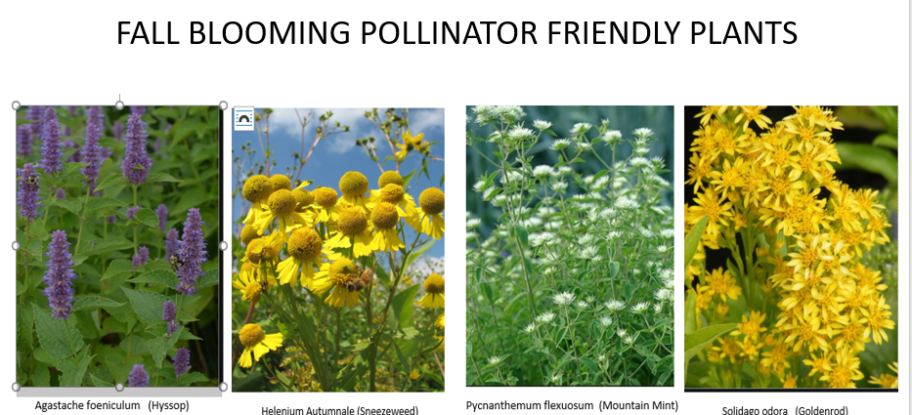
Logistics:
Plants will be grown in Parkside Greenhouses during summer of 2020. Ground preparation for plantings will commence 2nd week of September. Plantings will take place 3rd week of September. All work will be done by the Parkside Horticulture students.
See YouTube video below.
https://www.youtube.com/watch?v=zuoepOKEmz0&feature=share&fbclid=IwAR3EoLosKK92fdbj78wnhFVC1SsgxEy7WjOnw3xsVptj-OkV90qCxiThGwc

Budget.
Plants 200 x $3.50 = $700.00
-$350.00 -------------- FFA Living to Serve Grant Funding Secured
Total Y.E.A.S. Request = $350.00

