Youth Environmental Action Summit
Parkside High Pocket Meadow
Logistical Plan
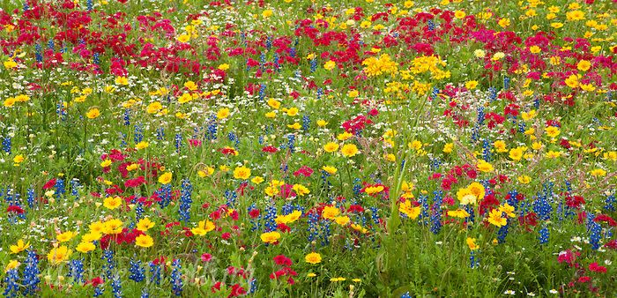

January 2019 Week 1:
Solicit Site Approvals: William Frisch WCBOE Facilities
Student Research
January 2019 Week 2:
Student Powerpoint Video Assignment Level 1 Horticulture
Student Budget Proposal
January Week 3:
Student Presentation Practice
Student Link Presentation to Youtube and A Plus Garden Centre Website
February Week 2:
Student Presentation/Proposal Jesse WCBOE Turf Contractor
April: Week 1: Yes Conference
May: Week 4:
Contractor Site Prep Review for Pocket 2,3
Purchase weed barrrier, seed.
Student install solarization weed barrier Pocket 1.
October: Week after first frost:
Final raking and seed sowing.

